Project Report

**Team information**

Team number 11, composed of Daniel Esparza, Tyler Fenske, and Justin DeSalvo, created the game “Wifi Hero”. Justin created the splash screen, the choose a difficulty screen, the end game screen, as the move/wraparound functions and objects on the screen where the game is played. Daniel created the summary page, added the move counter on the play screen, and was responsible for the general appearance of the project.

**Statement of the problem, significance**

The objective was to create a game involving a varying amount of satellites displayed on a map. The player would accumulate points by moving the satellites furthest away from each other and the game ends when all moves have been used. This project is significant because it gave us the experience of building our own game from beginning to end. It also teaches teamwork and allowed for creativity on the student’s side.

**Restrictions and limitations**

We were mostly limited by our own skills, this caused for a lot of referencing to the book and fltk documents online. One other limitation was the amount of reference documents for fltk and lack of community to call on for assistance. For one problem, the latest solved question online was from 2004 and had little to offer to our problem. Finally, the bug with the widgets caused for us to include button covers to show where the original widget was placed, and when the bug was fixed it caused a variety of problems and caused us to revert to the original bugged version.

**Explanation of your approach**

Upon reading the instructions we realized that it would be best to implement a modular like design to our code. This would allow for easy transition from any screen to a previous one. It was decided that just detaching and reattaching functions for each screen would allow for easy movement from screen to screen as well as an easy loop back from the end of the game rather than destroying screens completely and creating a new one. Also, we decided to have only one window that changed continuously throughout the game, simplifying our main. Comments were use to separate each section of the code. Functions and variables that are similar for different screens were named uniformly to avoid confusion, but numbered to avoid renaming.

**Sample Run**

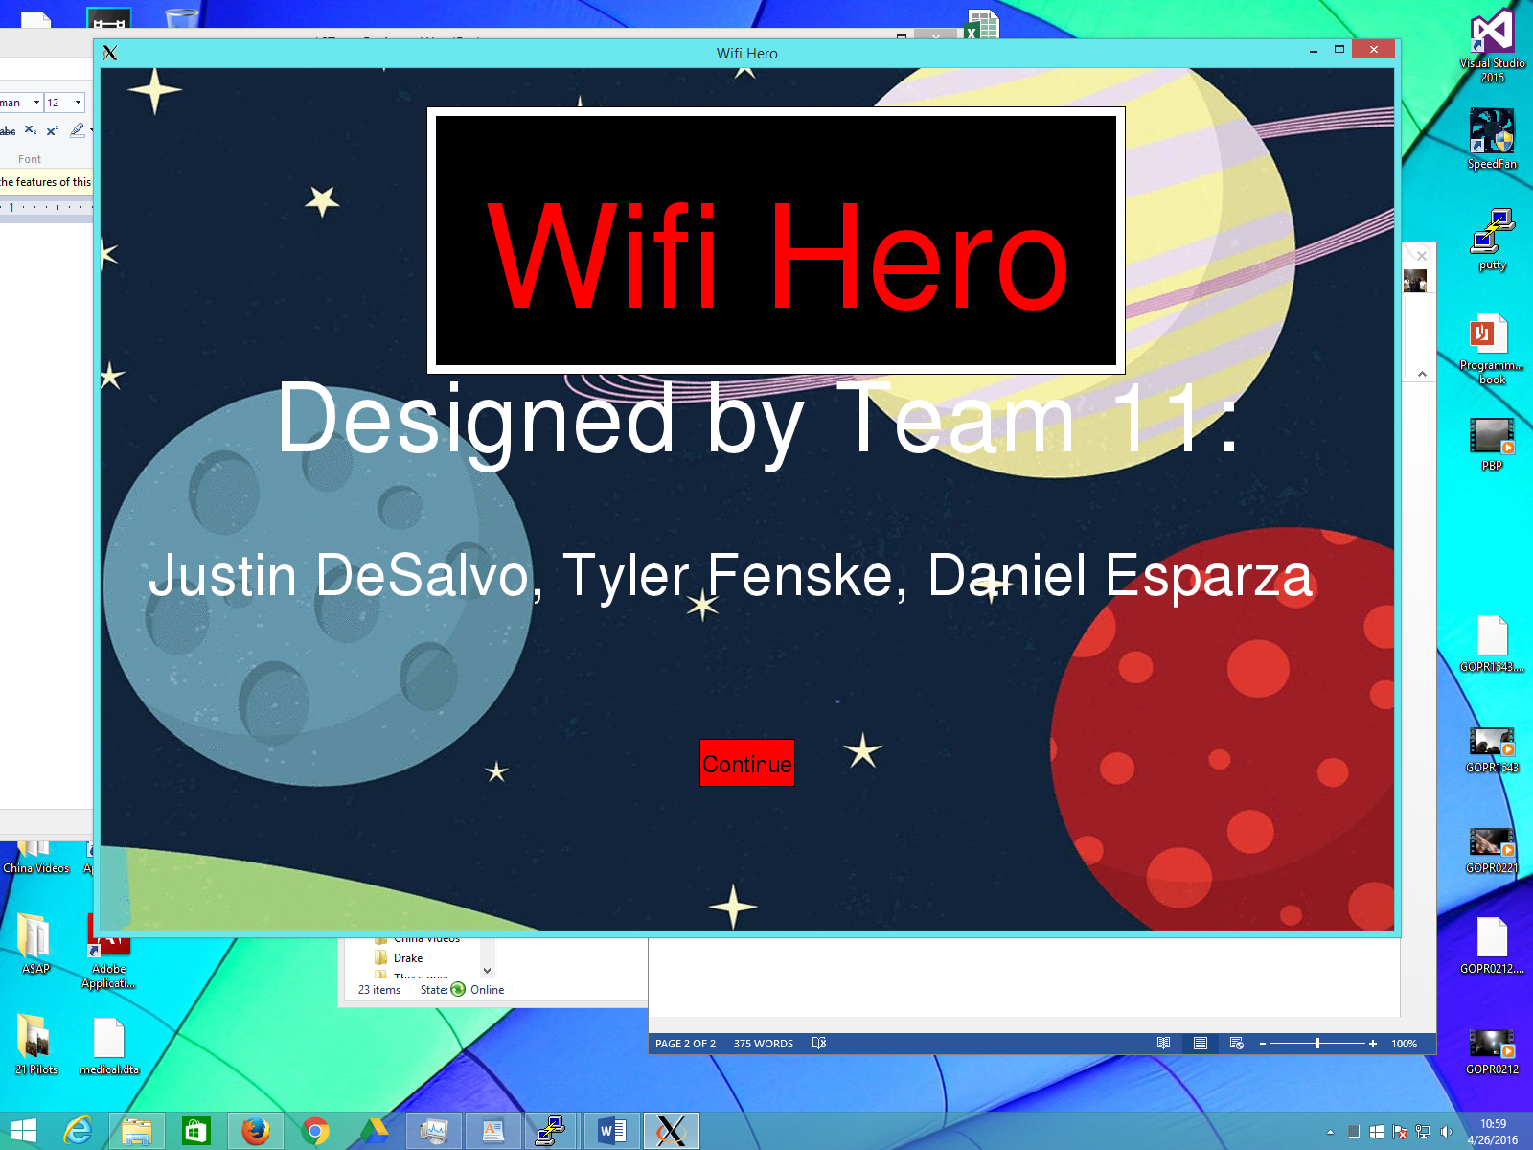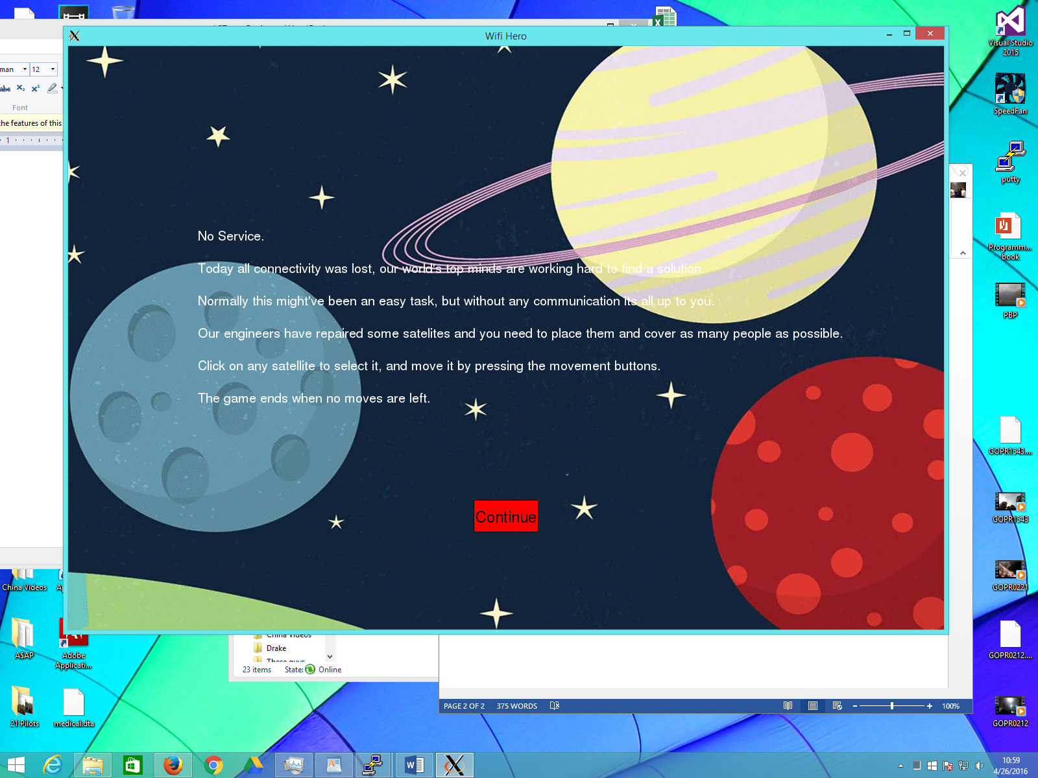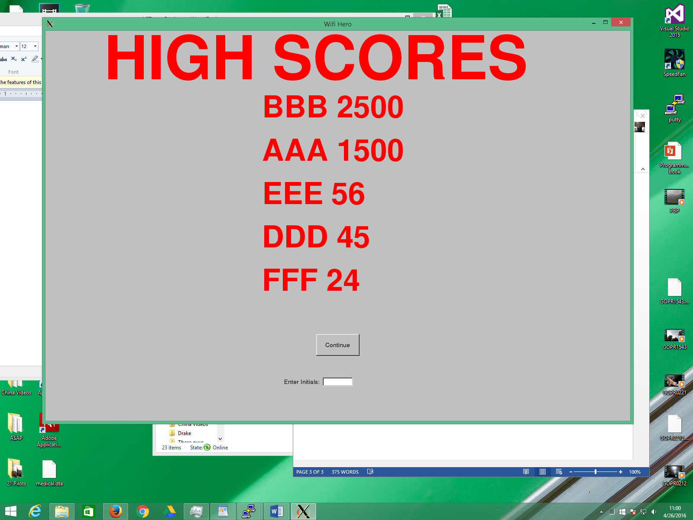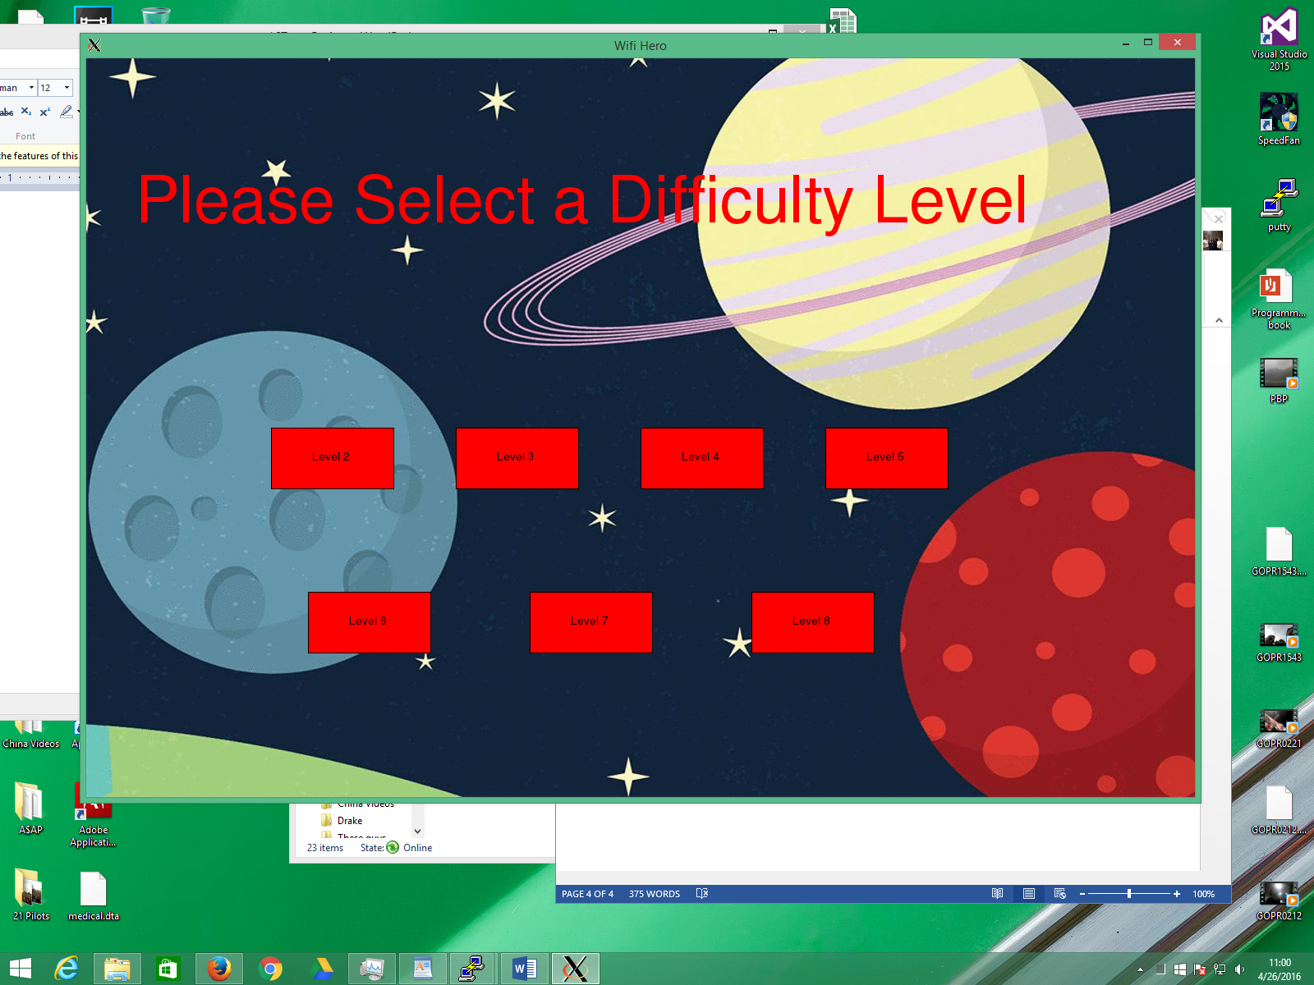

**Results and Analysis**

This game proved to be difficult as fltk was very buggy. Our main difficulties were with buttons being pressed. When we applied the fix to these bugs, more problems appeared from the widgets being drawn on top. It is best to plan as much as possible as you will run into issues and often have to go back and fix them later if you do not account for them to begin with. Timeliness is important, especially when working with a group. The importance behind good commenting was also very prevalent when coding with a group.

**Conclusions**

The impact that uniform coding has when coding with other people is huge. The idea that others need to be able to read your code, understand your code, and work with your code is very useful in a group setting. In programming, there are many ways to do one task, being able to explain how your code works through comments can make teamwork simple and more enjoyable.

**Future Research**

The program could be improved with a better graphics package that was less buggy when drawing in widgets and objects together. With more time, there could be simplification of the code within our program. In the future a more aesthetically pleasing look could be implemented, and the option to play the game on a three dimensional model.

**Running The Program**